District 7690
Reference Manual 2026-2027




Dr. Karen Pollard
District Governor
2026-2027

PETS district breakout Friday:
9-9:15AM Cold open with Discover Rotary DGN Anant Venkataraman
9:15-9:20AM Welcome and pledge DGN Anant Venkataraman
9:20-9:25 Introduce leadership team and AGs DG Mark Brandon
(wrestling intro style)
9:25-9:45 President basics (address pages of reference manual) DGE Karen Pollard
9:45-10:00 Membership to include MAP DMC Katie Walker
10:00-10:10 Break
10:10-10:25 Foundation DFC Elect Jim Fradenburg
10:25-10:40 District Action Committee with service project DAC Mark Hensley
10:40-10:55 Public Image DPIC Elect TBD
10:55-11:10 Youth Services DYSC Elect TBD
11:10-11:15 Wrap up and Announcements DLF Deanne Brown

Saturday
Q&A - What questions do you have and what clarifications do you need?
Conflict resolution, effective communication

Table of Contents
Your Year Begins Now! 4
District Learning and Events Dates 2026-2027 5
District Leadership Team 6
Area & Club Leadership 12
Rotary International Vision Statement & Strategic Priorities & Objectives 17
District Goals (Presidential Priorities) 18
District Strategic Plan 2026-2029 19
District Achievement Awards 20
Club Excellence Award 21
Rotary District Priorities 22
Club President’s Calendar 23-26
District Governor’s Club Visit Schedule 27 Club Brag Sheet 29
Membership Goals 2026-2027 30
Rotaract 31
Foundation Goals 2026-2027 32
District Grants 33
End Polio Now Goals PolioPlus Promise 35
District Peace Building Resource Guide 36
CART 37
Public Image 38
District Action 39
Youth Services 40
Rotary Leadership Institute (RLI) 41
Family of Rotary Day 2027 42
Crisis Management Guidelines 43 Rotary Club & District Liability Insurance Program 45
District Conference 2027 Back Cover



DISTRICT LEARNING & EVENT DATES
2026-2027
2026 | Event or Action Item | Location (If applicable)
March 19 - 21 | Carolinas' PETS | Sheraton @ Four Seasons Greensboro
March 31 | Submit RYLA student participation forms | Online to RYLA7690.org
April 11 | Duke-UNC Peace Spring Conference | FedEx Global Education Center (8am-4pm)
April 23-26 | DG Mark’s District Conference | The Crystal Coast, Atlantic Beach
April 30 | 26-27 District Grants MOU Due (DDF) | E-Signatures (PE and PN)
April 30 | 26-27 Youth Services MOU due | E-signature
May 15 | Final 25-26 DDF Grant Reports Due | Online (DACdb Grants Module)
May 15 | Enter 26-27 Membership & Foundation goals | Rotary Club Central
May 16 | District Learning Assembly (formerly DTA) | Randolph Community College (8:30- 2:30)
May 31 | New 26-27 DDF Grant Apps Due | Online
May 31 | Submit all club and member contributions | Online to The Rotary Foundation
June 13-17 | Rotary International Convention | Taipei, Taiwan
June 17-20 | RYLA | TBD
June 25 | District Officer Installation Dinner ( Karen) | Greensboro Country Club
July TBD | Submit your club’s dues | Online to RI and District
July 31 | Enter service goals | Online in Rotary Club Central
August 20 | Membership Summit | TBD
September TBD | Fall seminar | TBD
October TBD | Ray Taylor Memorial District Golf Tournament | TBD
October 24 | World Polio Day | Observed by Clubs Individually
October 27 | Incoming Presidents Orientation | 8am Zoom
October 28 | Incoming Presidents Orientation | Noon-In person lunch-TBD
October 29 | Incoming Presidents Orientation | 4pm Zoom
Nov TBD | Paul Harris Society Reception | TBD
Nov TBD | District Foundation Banquet | TBD
Dec 31 | Submit new officers | Online to RI
Dec 31 | Submit member and club foundation funds | Online to The Rotary Foundation
2027 | Event or Action Item | Location (If Applicable)
February 6 | Grants Management Learning | TBD (8:30am - 12:30pm)
February 27 | Four-Way Test District Speech Contest | TBD (9:00-2:00)
March 4-6 | Carolinas’ PETS | Sheraton Four Seasons Greensboro
April 22-25 | DG Karen's District Conference | Williamsburg, VA
April 30 | 27-28 District Grants MOU Due (DDF) | E-Signature
April 30 | 27-28 Youth Services MOU due | E-signature
May 15 | Final 26-27 DDF Grant Reports Due | Online (DACdb Grants Module)
May 1 | District Learning Assembly (DTA) | TBD (8:30 - 2:30)
May 31 | New 27-28 DDF Grant Apps Due | Online
June 5-9 | Rotary International Convention | Dubai, UAE
June TBD | RYLA | TBD
June 24 | District Officer Installation Dinner (Anant) | TBD

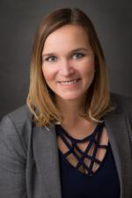
Karen Pollard
Rotary 7690 District Governor 2026-2027

Karen was raised in Centreville, VA. She attended her first year of college at Virginia Tech, but transferred to California for the remainder of her education. She double majored in psychology and Deaf studies at California State University Northridge and then earned her Master’s degree and Doctorate in Clinical Community Psychology from University of La Verne in Los Angeles county. Karen returned to the East coast for her post-doctoral fellowship in neuropsychology at University of Virginia. She began her career in clinical neuropsychology where she worked to diagnose and create treatment plans for clients struggling with cognitive issues, like Alzheimer’s disease and other dementias or Attention Deficit Hyperactivity Disorder. Karen is passionate about helping as many people as possible understand the unique ways that their brains work so that they can be more efficient and less stressed. She owns Brain Power Advisors and Brain Power Solutions where she helps business leaders and others learn to leverage their brain power to benefit them in life.

Karen joined Rotary in 2018 soon after starting her first business. She very quickly found her home in Rotary and has enjoyed interacting with Rotarians across the district through public speaking and make-up meetings. In her short time, she has served her club in roles such as membership chair, fundraising chair, Vice President and President. She has also served at the district level as trainer, conference chair, assistant governor, and on the membership committee. Karen is an RLI graduate and facilitator and was part of a zone 33 team that helped update the curriculum and transition to online RLI classes. Karen is a Paul Harris Fellow and Paul Harris Society Member. She has also signed the Polio Plus Promise. She has spearheaded an approved global grant to bring clean water to a village in rural Jamaica and hopes one day to expand that project so that all Jamaicans have reliable access to clean water.

Karen recently married her husband, Kevin, and their blended family includes four daughters. She currently lives in Summerfield. She is also an adventurer; she was part of a group that raised funds to start a cervical cancer screening clinic in a remote region of Tanzania and while there, she and her team climbed Mt. Kilimanjaro. In her spare time, she enjoys traveling, playing piano, and playing poker.

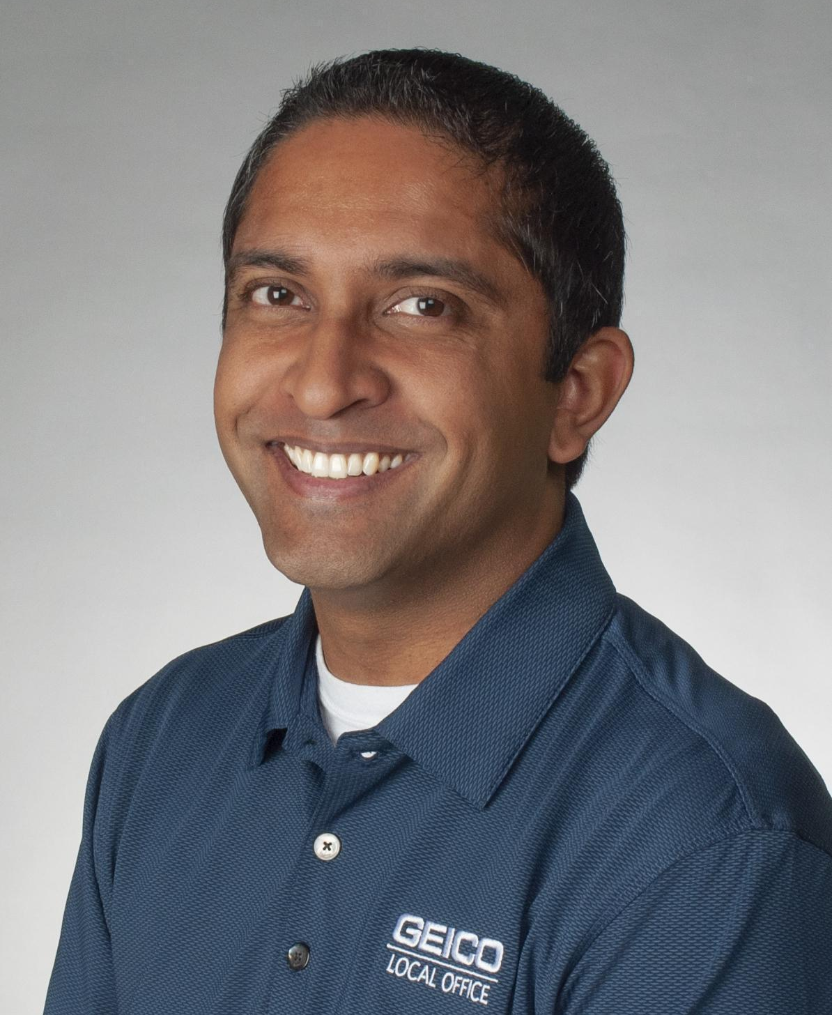

Anant Venkataraman
Rotary 7690 District Governor 2027-2028
Anant was born in Allentown, Pennsylvania. After moving a couple of times during his
initial years, his family finally relocated to Morgantown, West Virginia. After high school,
he attended the University of Pennsylvania and graduated from The Wharton School of
Business. With a successful and rewarding career in the nonprofit world behind him, he
shifted gears and began a life in the insurance world, getting his insurance license and
start with the local Geico office in Morgantown. He started at the bottom as a dialer then
moved his way up the ranks as a sales agent, top sales agent, then Office Manager. He
eventually became Business Manager for both the offices in Morgantown and
Charleston, West Virginia. In 2018, he was driven by his boss and mentor to open his
own office and in May of 2019, he started Geico Winston-Salem which quickly became
the fastest growing insurance agency in the state.

Not only did Anant find success in insurance but he also found success in his personal
life as he married the girl of his dreams, Richa Talwar, in 2020 and have been happily
married ever since. They recently welcomed their daughter Alara Rian into the world in
November of 2025 and also have one four-legged feline child, Oliver Wendell. The four
currently reside in Burlington, NC.

Anant was urged by his former boss, Jim Robinson, to join Rotary while in Morgantown
as a corporate member in 2018. While there, he quickly fell in love with the service and
fellowship side while building a solid business network. In 2019 when he moved to
Winston-Salem to start his own insurance agency, his first priority was to find a local
Rotary club to transfer to and for networking purposes. His first visit was to the Rotary
Club of Western Forsyth and his search was over. In his short time, he has served his
club in roles such as Treasurer, Vice President and President. He has also served on
the district level as a member of the Foundation and Finance committees, on the
Membership Committee as Attraction Chair and MAP Ambassador, and additionally
served as Area 4 Assistant Governor. Anant is also an RLI graduate, Paul Harris
Society Member, Benefactor, Bequest Society Member, and most recently became a
Major Donor. He is very proud to be a member of the Polio Plus Promise club. In his
free time Anant enjoys any and all sports, travelling, and spending time with his family
and friends.

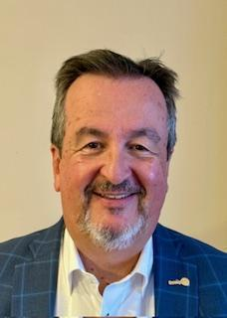

Mark Hensley
Rotary 7690 District Governor 2028-2029
Mark was born in Marion, NC. He attended & graduated from North Carolina State University and the University of Virginia’s Darden School of Business.

Mark spent 38 years as a banker before retiring as an Executive Vice President/Chief Banking Officer. Mark’s banking career took him to 7 different cities in the Carolinas with the final move being to Asheboro, NC in 2001. After only two months of retirement, Mark returned to the workforce as the Executive
Director of a nonprofit organization, the Randolph Senior Adults Association. Mark served the Senior Adult community for 7 years and retired again on June 30, 2025.

Mark married Beth in 1987, and they are the parents of one daughter, Gracie. Beth retired after a career in the pharmaceutical industry. Gracie is a Pediatric Cardiac ICU Nurse at Duke Hospital who also has an MBA in Healthcare Management from High Point University. As of May 2026, Gracie will start her
Doctor of Nurse Anesthesia Practice at the University of South Carolina with an anticipated completion date of May 2029.

Mark has served or is currently serving on many boards and committees since moving to Asheboro. He was a founding school board member of the Uwharrie Charter Academy; the statewide board of Habitat for Humanity; Chairman of the board for Hospice of Randolph County; Treasurer of the board of the United Way
of Randolph County; Grants Chair for the Community Foundation of Randolph County; Treasurer of RhinoLeap Theatre Productions; the Chamber of Commerce; and the Randolph Hospital Foundation.

Mark joined the Rotary Club of Asheboro in 2018 and is a Paul Harris Fellow, Paul Harris Society Member and a Bequest Society Member. He has served as Club President; District Action Coordinator; District Club Assistance Team Lead; and Grant Administrator for District 7690’s Good Night Grant program. Mark was
selected as the DGND of 7690 in September of 2025.

Mark is a huge football fan – especially the Wolfpack and Carolina Panthers; loves all forms of music; and enjoys the pursuit of high-end bourbon.

District Executive Committee

District Governor 2026-2027  Karen Pollard  Crescent Rotary Club | District Governor 2027-2028  Anant Venkataraman  Western Forsyth Rotary Club | District Governor 2028-2029  Mark Hensley  Asheboro Rotary Club
  Immediate Past District  Governor Mark Brandon  Yadkin County Rotary Club | 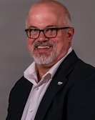  District Action Chair  Kelsey Brown  Troy Rotary Club |   Public Image Chair  Grant Welch  Sanford Rotary Club
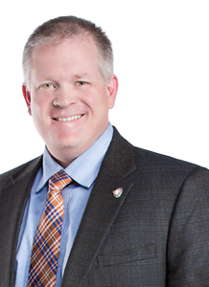  Rotary Foundation Chair  Jim Fradenburg  Kernersville Rotary Club | 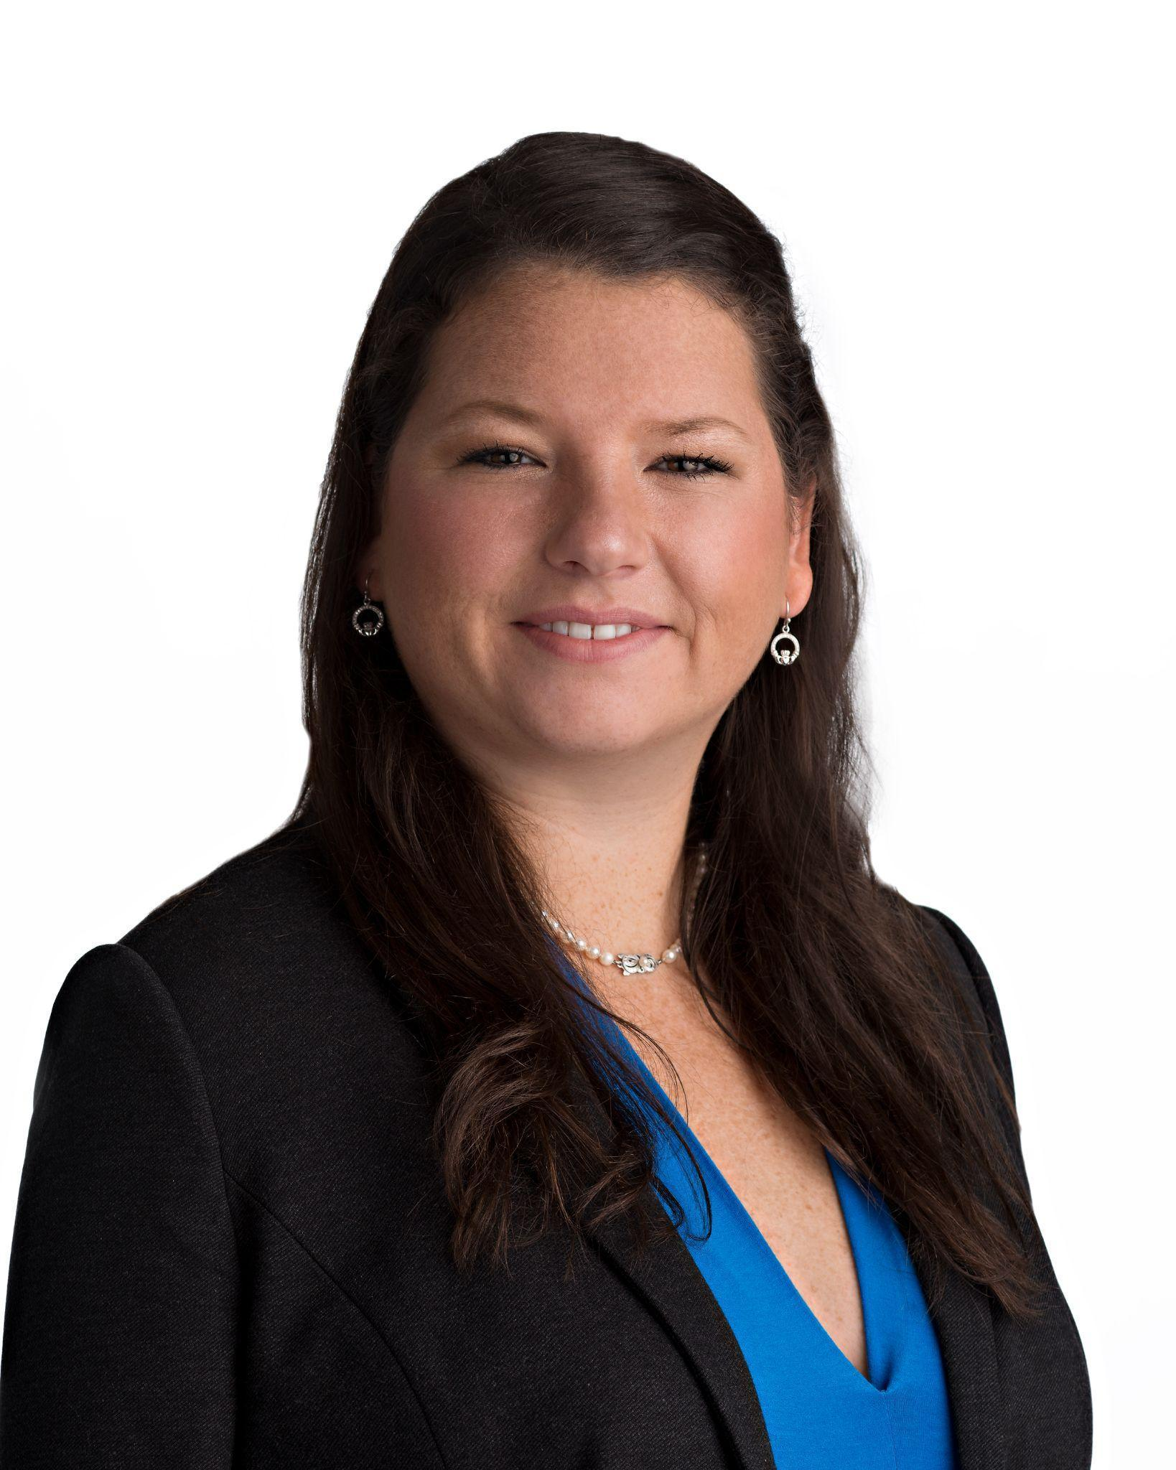  Membership Chair  Katie Walker  Pittsboro Rotary Club |   Youth Services Chair  Courtney Cabe  Pittsboro

District Organization Chart
► District Leadership Team ◀
District Governor Karen Pollard Crescent 818-585-2469
District Governor Elect Anant Venkataraman Western Forsyth 304-685-2902
District Governor Nominee Mark Hensley Asheboro 336-963-0430
District Governor Nominee Designate TBD 2026
Immediate Past District Governor Mark Brandon Yadkin County 336-407-0643
One Past Immediate Past District Governor Ron Pierce Guilford 336-686-8090
Vice Governor * Jon Spillman Downtown Greensboro 336-707-2749
Assistant Governors See page 12…
District Administrator Steve Dolat Crescent 860-367-6913
Membership Chair Katie Walker Pittsboro 910-391-5531
Foundation Chair Jim Fradenburg Kernersville 336-403-3784
Public Image Chair * Grant Welch Sanford 919-706-6419
Youth Services Chair * Courtney Cabe Pittsboro 919-272-8573
District Learning Facilitator 2025-2027 * Deanne Brown Troy 910-220-1384
District Treasurer James Gouty Asheboro 336-953-0008
* Non-Voting Member of the Executive Committee

► Finance Committee ◀

District Treasurer (Chair) James Gouty Asheboro 336-953-0008
Committee Members
District Governor Karen Pollard Crescent 818-585-2469
District Governor Elect Anant Venkataraman Western Forsyth 304-685-2902
Immediate Past District Governor Mark Brandon Yadkin County 336-407-0643
One Past Immediate Past District Governor Ron Pierce Guilford 336-686-8090
Past President Charlie Rowe Clemmons 336-414-0682
Past President Alec Pratto Crescent 336-209-7853
Audit & Stewardship * Randall Hayes Crescent 336-286-6470
Mark Kolada Summit 336-708-2503
* Independent (reports to Executive Committee)

► Membership Committee ◀

District Membership Chair Katie Walker Pittsboro 910-391-5531
Subcommittee Chairs
Engagement Van Lankford Mount Airy 336-407-1579
Attraction Scott Allen Asheboro 336-215-8156
New Club Creation Grant Welch Sanford 919-706-6419
Public Image Shanon Suggs Welch Sanford 919-770-4932
Rotaract
Discover Rotary Liason Anant Venkataraman Western Forsyth 304-685-2902
CAT Lead Dale Badgett Surry Sunrise 336-326-8889
Membership Summit Chair Grant Welch Sanford 919-706-6419

District Organization Chart

► Foundation Committee ◀
District Foundation Chair Jim Fradenburg Kernersville 336-403-3784
Subcommittee Chairs
Fundraising Krystal Tyndall Surry Sunrise 910-369-3226
Annual Fund Mike Conrad DTN Greensboro 336-404-0951
Major Donor/Endowment Doug Gardner Clemmons 336-416-7715
Paul Harris Society Van Lankford Mount Airy 336-407-1579
Polio Plus Charles Allen Randolph (Asheboro) 336-963-2428
Foundation/PHS Reception Tanya Feagins Greensboro Airport 336-669-6399
Grants
Global Grants Debbie Doby Carthage 352-665-8282
District Grants Mary Joan Pugh Asheboro 336-963-2715
Julie Talbert Eden 336-613-1742
Peace Fellows/Centers/Builder Clubs Scott Wagoner Alamance 336-989-1971

► Youth Services Committee ◀
Youth Services Chair Courtney Cabe Pittsboro 919-272-8573
Subcommittee Chairs
Youth Exchange/Friendship Exchange Ed Woodall Alamance 336-213-2978
Interact Courtney Cabe Pittsboro 919-272-8573
4 Way Speech Contest Kathy Homiller Asheboro 336-626-7658
RYLA Chair Lynn Michael Reynolda 336-464-6415
Child Protection Steven Taylor Graham 919-270-7257
Youth Peace Initiative Scott Wagoner High Point 336-407-1579

► Public Image Committee ◀
Public Image Chair Grant Welch Sanford 919-706-6419
District Photographer Phil Morris Furnitureland 336-848-7525
Website Ron Pierce Guilford 336-686-8090
District Newsletter Steve Dolat Crescent 860-367-6913
► Learning Committee ◀
District Learning Chair 2025-2027 Deanne Brown Troy 910-220-1384
PETS Anant Venkataraman Western Forsyth 304-685-2902
Rotary Leadership Institute Scott Wagoner High Point 336-407-1579
► Event and District Support Committee ◀
District Conference Chair Mark Hensley Asheboro 336-963-0430
District Golf Tournament
International Convention Anant Venkataraman Western Forsyth 304-685-2902
Family of Rotary Caren Osborne Pittsboro 860-878-0172
Rotary Means Business Amy Jacobson Gate City Sunset 978-290-1566
Governor’s Assistance Cathy Harpster Southern Pines 910-690-1101
CART Chair John Revell Asheboro 336-465-1733

District Assistant Governors

AREA 1  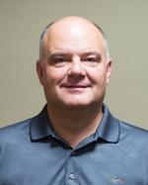  DALE BADGETT  AG - YEAR 1  Surry Sunrise  Mount Airy  Mount Airy (SAT)  King  Surry Sunrise  Yadkin County  Yadkin Valley | AREA 2    FRED THOMPSON  AG - YEAR 2  Reidsville  Eden  Madison-Mayodan  Reidsville  Stoneville | AREA 3    RUSSELL GUY  AG - YEAR 3  Alamance  Alamance  Rotario Hispano de Alamance (SAT)  Burlington  Graham
AREA 4  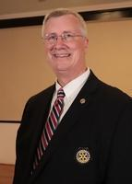  CRAIG DEPUY  AG - YEAR 1  Clemmons  Clemmons  Reynolda  Western Forsyth  Maple Chase (SAT) | AREA 5    KEIR DAVIS  AG - YEAR 1  Summit  Downtown Greensboro  Triad IMPACT  East Greensboro  Greensboro  Guilford | AREA 6  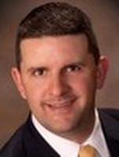  KEN ESPOSITO  AG - YEAR 2  High Point  Furnitureland  High Point  HP IMPACT  Jamestown
AREA 7  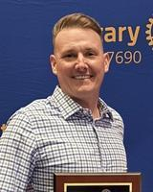  JASON TUGGLE  AG - YEAR 1  Thomasville  Global Trekkers  Lexington  Mocksville  Thomasville | AREA 8    DAWN MORTON  AG - YEAR 2  Asheboro  Asheboro  Midstate  Randolph  Liberty  Troy | AREA 9    FRAN GRANDINETTI  AG - YEAR 2  Pinehurst  Carthage  Northern Moore (SAT)  Pinehurst  Sandhills  Southern Pines
AREA 10    PATRICK WALSH  AG - YEAR 1  Pittsboro  Pittsboro  Sanford  Siler City | AREA 11  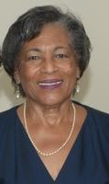  SANDRA ROSEBOROUGH  AG - YEAR 2  Southern Guilford  Crescent  Gate City  Gate City Sunset (SAT)  Southern Guilford  Summit  Skills and Service (SAT) | AREA 12    LISA PARRISH  AG - YEAR 2  Winston-Salem  Kernersville  Kernersville Evening (SAT)  Stratford (WS)  Winston-Salem

2025-2026 List Of Club Presidents

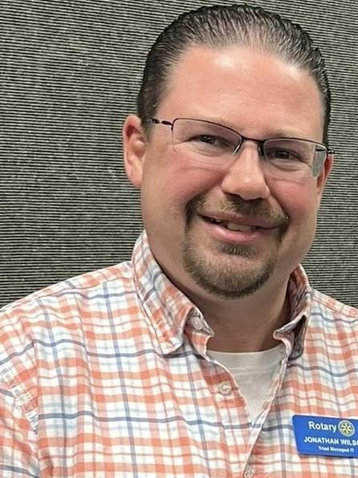  Alamance  Jon Wilson  336-567-7429 |   Asheboro  Lisa Hayworth  336-687-6909 |   Burlington  Dave Eggleton  603-491-3977
  Carthage  Donna Rizzi  910-783-7301 |   Clemmons  Wendy Taylor  336-749-6424 |   Cresent  Francis “Ed” Widman  336-509-1936
  Downtown Greensboro  Matthew “Matt” Blake  336-580-5355 | East Greensboro  Karen Jackson  336-508-0919 |   Eden  Vondra Higgs  336-932-9878
  Furnitureland  Mark Ayer  336-687-6813 |   Gate City  David Lillard  336-312-2167 |   Global Trekkers  Kathy Trost  910-261-4425
Graham  Joan “Carol” Walker  336-380-6813 | 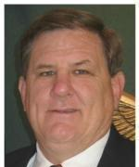  Greensboro  Gary Stasco  336-646-3161 |   Greensboro Airport  Eric Weaver  336-402-8182
  Guilford  Amanda Somers  336-362-9265 |   High Point  Scott Wagoner  409 Sterling Ridge Dr  Archdale, NC 27263  336-989-1971 |   Jamestown  Angela Morrow  336-580-2463

2025-2026 List Of Club Presidents

  Kernersville  William “Monte” Long  336-992-5664 |   King  Brian Spencer  336-782-8078 |   Lexington  Walter Hoffman  336-225-8868
  Liberty  Nick Mooney  727-492-7349 | Madison-Mayodan  Georgianna Penn  757-243-4955 | Midstate  Sharon Castelli  910-986-2332
  Mocksville  Monica Stone-Huggins  919-891-3724 | Mount Airy  Kevin Joyce  336-655-4990 |   Pinehurst  Peter Fore  312-764-3510
  Pittsboro  Eric Williams  919-906-9104 | 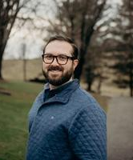  Randolph  Matthew “Matt” Higgs  336-465-3688 | 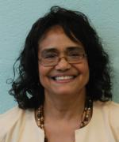  Reidsville  Leanna Lawson  336-613-2565
  Reynolda  Sean Talbott  717-329-2972 | Sandhills  Brent Stark  720-281-3949 |   Sanford  Linda Berryman  919-770-0244
Siler City  Alfred “Al” Devine  631-871-9294 | 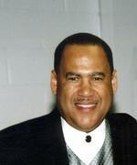  Southern Gilford  Lonnie Cathey  336-327-6004 |   Southern Pines  Alva “Chip” Cromartie  336-601-0464

2025-2026 List Of Club Presidents

  Stoneville  Mitzi Evans  336-432-6779 |   Stratford  Sheldon Moser  336-972-8299 | 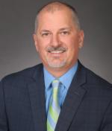  Summit  Mark Kolada  336-708-2503
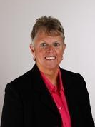  Surry Sunrise  Debbie Watson  336-325-5338 | 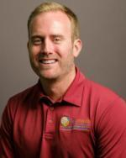  Thomasville  Cory Tobin  336-905-0203 | 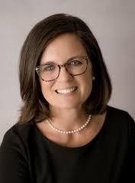  Troy  Melanie McLeod  910-992-2451
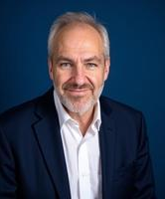  Western Forsyth  Robert “Bob” McGurty  417-569-7810 |   Winston-Salem  Katie Hall Nicolas  336-749-0720 |   Yadkin County  Robin Nance  336-244-3055

Yadkin Valley

Desiree Mastin
336-466-1054



Rotary International President

Olayinka Hakeem Babalola
Rotary Club of Trans Amadi Rivers State, Nigeria
President 2026-2027

Olayinka Hakeem Babalola received a university degree in engineering in 1988. He worked for 25 years in the oil and gas industry, holding senior positions at Shell PLC. He is the founder of two companies: Riviera Technical Services Ltd., an oil and gas infrastructure delivery company, and Lead and Change Consulting, an executive coaching and organizational performance advisory group.
Babalola’s professional affiliations include the Nigerian Society of Engineers, the Institute of Safety Professionals of Nigeria, and the Association of Change Management Professionals. He is a member of Jericho Businessmen Club, an organization in his birth city of Ibadan that provides input to governments on economic and social policy.
A Rotaractor for 10 years, Babalola has been a member of the Rotary club of Trans Amadi since 1994 and served as district governor in 2011-12. He served on the RI Board of Directors (2018-20) and was vice president in 2019-20. He has served on committees including the End Polio Now Countdown to History Campaign Committee (2017-23, vice chair 2017-20) and the Nigeria National PolioPlus Committee (2013-present, adviser 2016-present).
Babalola and his wife, Preba, live in the city of Port Harcourt. He supports The Rotary Foundation with a named endowment and as an Arch Klumph Society member. He volunteers as a trustee for ShelterBox UK. He has received the Africa Centennial Heroes Award, the Regional Service Award for a Polio-Free World, the RI Service Above Self Award, and The Rotary Foundation Citation for Meritorious Service.

2026-2027 Presidential Priorities

FIND Joy Through Rotary Involvement
EMPOWER Members to Lead
IMPACT Communities by Doing “Good Stuff”
ENSURE Every Child Has a Bed to Sleep In through District Initiatives
COLLABORATE with Other Clubs to Enhance Impact
MAKE Fundraising FUN to increase support of The Rotary Foundation and Polio Plus
PROMOTE Rotary’s Impact Through Strong Public Image
INVOLVE Youth as the Future of Rotary
CONTINUE Learning and Growing Every Day
CREATE Welcoming Environments Where All People and Ideas are Valued
PROVIDE Opportunities for Business Networking
FOCUS on the Club Experience
TRY New Approaches Without Fear
CREATE New Opportunities for Membership in Rotary
PLAN for Succession in Your Club
UTILIZE District Achievement Awards as a Key Performance Indicator for your club’s success
BE a Rotary Superfan
LIVE The Four-Way Test

Rotary District 7690 — 3-Year Strategic Plan Framework (2026–2029)
Vision:
Rotary District 7690 will be recognized as a growing, connected, and innovative district where clubs thrive, members find joy in service, and communities see Rotary as a trusted partner for lasting impact.
Rotary International Priority | District 7690 Strategic Focus
Increase Our Impact | • Grow support for The Rotary Foundation & PolioPlus  • Prioritize measurable, high-impact projects  • Encourage global & district grants  • Share impact stories broadly
Expand Our Reach | • Achieve consistent membership growth  • Launch innovative club models  • Use public image to drive awareness & growth  • Build partnerships with community organizations
Enhance Participant Engagement | • Strengthen youth programs: Interact, Rotaract, RYLA, Exchange  • Encourage club member leadership involvement  • Promote collaboration across clubs  • Support meaningful member experiences
Increase Our Ability to Adapt | • Modernize communication & leadership tools  • Encourage innovative club models & flexibility  • Gather annual feedback & adjust priorities  • Foster collaboration & best practice sharing

Vision 26-27: District Achievement Awards

Coming Soon!!

Club Excellence Award
The Club Excellence awards, formerly the Rotary Citation awards, recognize clubs that achieve specific goals throughout the year, such as increasing their membership, engaging members in sustainable service projects, giving to The Rotary Foundation, building awareness of Rotary in your community, and having an up-to-date strategic plan. When clubs achieve these goals, they contribute to Rotary's overall health and culture for generations to come.

Rotary and Rotaract Club Excellence Awards
Rotary and Rotaract clubs can find their goals in Rotary Club Central. To achieve the Club Excellence Award, review all the available goals, select at least half of them, achieve those goals, and report your achievement in Rotary Club Central.
All achievements need to be reported in Rotary Club Central by 30 June.

Interact Club Excellence Award
Interact clubs that achieve and report achievement of the Interact goals by 15 August will earn a Club Excellence award.
To receive an award, the sponsor Rotary club’s president completes the online nomination form by 15 August to access and complete the downloadable certificate template before presenting it to the Interact club. For Interact clubs with more than one sponsor club, only one nomination should be submitted for any given Interact club.
Only clubs with an active charter with Rotary International are eligible for the award. Rotarians can check the Listing of Club-Sponsored Organizations in Rotary Club Central to confirm that an Interact club is active.

Resources and reference
- Club Excellence Goals and Instructions for Rotary and Rotaract Clubs (PDF)
- Club Excellence Goals and Instructions for Interact Clubs (PDF)
- Club Excellence Award Frequently Asked Questions (PDF)
- How to create a My Rotary account (PDF)
- How to Update Interact Club Information (PDF)

Rotary support
Questions? Write to rotarysupportcenter@rotary.org

Rotary District 7690 Priorities
2026-2027 Governor Dr. Karen Pollard

Finding Joy Through Rotary
“If Rotary is not bringing you joy, you need to change how you’re doing it.”
• Encourage every member to seek joy in service, fellowship, and leadership opportunities.
• Support clubs in creating welcoming environments where people feel valued and inspired.
Collaborate for Greater Impact
Our motto “Service Above Self” extends beyond the boundaries of a single club.
• Think bigger than your club:
- Partner with neighboring clubs on service projects.
- Collaborate on membership efforts to strengthen Rotary together.
- Share resources, ideas, and leadership opportunities.
• When we work together, we can accomplish more.
Sweet Dreams Initiative
Together, we begin the journey to ensure no child in our 15 counties sleeps on the floor.
• Current reality: 11,000 children without beds across our district.
• Our mission: “11,000 to none and Rotary has won!”
• Every club can take part—through hands-on building, fundraising, or partnerships with local organizations.
Call to Action
• Inspire joy in Rotary.
• Work together beyond club borders.
• Transform lives through Sweet Dreams.
Together, District 7690 will create lasting impact and find joy through service.

CLUB PRESIDENT’S CALENDAR ROTARY YEAR 2026-2027
Success leading your Rotary club is determined long before you are sworn in as President. The most difficult part of the process is the six months before installation. Begin the planning process now and you will be better prepared to implement the activities and assignments during that period without being overwhelmed. This is a general outline you can tailor to the practices of your Club and your own goals and objectives.
January 2026 (6 months): Vocational Service Month
- Meet with your Area Governor, President, Foundation and Membership Chairs to review the mid-year progress towards the club’s goals and objectives.
- Check club’s progress on achieving the 2025-2026 Best Practices/ District Achievement Award.
- Review with your President the club’s current budget.
- Work on your draft calendar and Club Goals for your year.
- Make sure you know how to access and use the District Database and RI’s Rotary Club Central (myrotary.org) Use your AG as a resource to navigate these.
- Register for PETS, March 19-21 at the Sheraton/Koury Convention Center. (Must attend PETS and should bring President Nominee as well) Notify DGE Karen Pollard and team if you are unable to attend Carolina’s PETS &amp; then attend an out-of-district PETS session. Registration closes February 7, 2026.
- Register to attend Grants Management Learning Seminar on February 7, 2026, at Randolph Community College.
- Complete the Online Grants Management Learning Module sent via email. One club member MUST complete this and send attestation to Deanne Brown and Cathy Harpster BEFORE February 7, 2026 to be eligible to receive District Designated Funds for district grants.
February 2026 (5 months): Peace and Conflict Prevention/Resolution Month
- Attend Grants Management Learning Seminar on Feb. 7, 2026
- If you have not already, Register for March 19-21 PETS. (See details above.)
- If not completed already, register to attend District Conference #26, April 23-26, Crystal Coast in Atlantic Beach, NC
- Attend Jim Armstrong Memorial 4-Way Test District Speech Contest to be held on Saturday, February 28, 2026.

March 2026 (4 months): Water and Sanitation Month
- Attend PETS on March 19-21.
- If not completed already, register to attend District Conference#26.
- Register to attend the District Learning Assembly (formerly DTA) event on May 16, Randolph Community College, Asheboro.
- Meet with your new board to finalize committee assignments, budget, projects, and calendar.
- Submit RYLA Student Participation Form by March 31.
April 2026 (3 months): Maternal and Child Health Month
- If not completed already, register to attend the District Learning Assembly on May 16.
- Submit 2026-27 DDF MOU (Memorandum of Understanding) by April 30. (2 electronic signatures required: PE/PN preferred)
- Submit 2026-27 Youth Services MOU (Memorandum of Understanding) by April 30. (1 electronic signature required)
- If it is not completed already, register and attend District Conference#26 at Atlantic Beach.
- Finalize committee assignments, budget, goals, and calendar with your new Board of Directors.
- Determine your District Grant and/or Global Grant projects for 2026-2027 and ensure applications are in process.
May 2026 (2 months): Youth Service Month
- Ensure final reports for previous year’s District Grants (2025-2026) have been submitted to the District Grant Chair by May 15.
- Ensure Club Goals for Membership and Foundation are entered in Rotary Club Central by May 15 for DAA.
- Attend District Learning Assembly (formerly DTA) in May.
- Ensure application(s) for District Grant project(s) are submitted to District Grant Chair NO LATER than the deadline date of May 31.
- Promote attendance & register to attend the District Officer Installation Banquet on June 25, 2026 at Greensboro Country Club.
- Ensure all club and member contributions to the Rotary Foundation for the 2025-2026 Rotary year have been submitted by May 31, 2025.
- Hold a Club Assembly before taking office on July 1. Review Club Goals with your membership and ensure Club Committee Chairs present plans and objectives to the members. Confirm your club’s official visit from the Governor and share with club members to reserve the date.
- Schedule your quarterly club assemblies and club fellowship events for the 2026-27 year.
June 2026 (1 month): Rotary Fellowships Month
- Attend Rotary International Convention June 13-17, 2026, in Taipei, Taiwan.
- Remember RYLA is June 17-20. Registration required.
- Attend District Officer Installation. Encourage club members to attend as well. (See details above.)
- Ensure contributions for the year for each member have been submitted to the RI Foundation. (Should have been submitted for all by May unless a new member has been added in June).
- Hold a Club Officer Installation event to install club officers.
July 2026: CONGRATULATIONS!! READ DISTRICT NEWSLETTER
- Congratulations, you are now President!
- Inform club members of the club’s official visit date from the Governor. Start prepping!
- Submit dues to RI and to District 7690.
- Ensure that the Club Membership chair or Membership Committee member plus one more club member are registered to attend the District 7690 Membership Summit 2026 on Thursday, August 20 at TBD.
- Ensure club officers and committee chair positions are to Phil Morris for entry into District Database by July 15 and member information is current – this is a critical necessity to promote timely communication to club chairs and officers from RI and the district.
- Ensure Club Goals for Membership and Foundation are entered in Rotary Club Central by July 15.
- Ensure Service Goals are entered in Rotary Club Central by July 31.
August 2026: Membership and Extension Month
- Depending on DG visit schedule, prepare for the club’s official visit from the Governor.
- Ensure that the Club Membership chair or Membership Committee member plus one more club member attends the District 7690 Membership Summit 2026. (See details above.)
- Encourage club golfers to enter the District Golf Tournament (Ray Taylor Memorial) in October.
- Encourage Club Committee leaders and members to register and attend the Fall Learning Seminar in September.
September 2026: Basic Education and Literacy Month
- Depending on DG visit schedule, prepare for the club’s official visit from the Governor.
- Review your “Club Membership Growth Plan” for 2026-2027 that was developed at the Membership Summit 2026 and adjust strategies to continue member engagement, retention and attraction efforts. Communicate plans with your Board. Also share plan and any modifications with your District Membership Chair, Assistant Governor, District Governor and Club Assistance Team.
- Ensure that club leaders and members attend the Fall Learning Seminar September..
- Encourage club golfers to register to play in the District Golf Tournament (see details above.)
- If pursuing recognition, check in with Committee Chairs on DAA progress.
- Encourage your PE and PN to register to attend Incoming President’s Orientation meeting with DGE Anant Venkataram. Three options: Tuesday, 10/27 – 8am zoom; Wednesday, 10/28 – Noon, in-person, TBD; or Thursday, 10/29 – 4pm zoom,
October 2026: Economic and Community Development Month
- Depending on DG visit schedule, prepare for the club’s official visit from the Governor.
- Ensure team and/or players attend the District Golf Tournament on October XX.
- Follow up with the Club Nominating Committee to ensure candidates are considered for next year’s officer slate.
- Promote registration for the District Foundation Banquet on November XX, TBD
- Ensure club has a Foundation program planned for at least one meeting in November,
- Participate in World’s Greatest Meal event to raise funds for Polio Plus the week of October 24th
- Celebrate World Polio Day on October 24
- Encourage President-Elect to take advantage of the early registration discount and to register for the Carolinas’ PETS to be held March 4-6, 2027 at the Sheraton, Greensboro. (PE Must attend PETS and is encouraged to bring President Nominee as well) Notify DGE and team if PE is unable to attend &amp; arrange for him/her to attend an out-of-district PETS session.
- PEs attend one of the IPO sessions: 10/27, 10/28, or 10/29. (see details above)
November 2026: Rotary Foundation Month
- Depending on DG visit schedule, prepare for the club’s official visit from the Governor.
- Encourage club members and spouses to attend the annual Rotary Foundation Banquet.
- Encourage club members who are Paul Harris Society members to attend the Paul Harris Society Reception immediately before The Foundation Banquet on November XX at TBD.
- Review the club’s foundation report with the club Foundation Chair. Ensure contributions are being submitted to The Rotary Foundation in a timely manner.
- Hold a club meeting on a Foundation topic.
- Consider early registration and promote the International Convention to be held May 22-26 in Dubai, UAE
- Promote achieving and maintaining the Triple Crown Club status.
- Promote club members’ attendance at the DC#27 on April 22-25 in Williamsburg, VA.
December 2026: Disease and Prevention Month
- Hold elections for officers and board members, with the results reported to RI by December 31, through Rotary Club Central.
- Submit all member and club Foundation funds collected from July to December to The Rotary Foundation by December 31.
- Promote club members’ attendance at the DC#27 on April 22-25 in Williamsburg, VA.
- If pursuing recognitions, check in with Committee Chairs on DAA progress.
- Ensure Club Youth Services Committee Chair is promoting RYLA applications and the Rotary Four Way Speech Contest to the area High Schools.
January 2027: Vocational Service Month
- Review mid-year progress towards the club’s goals and objectives.
- Continue to monitor club’s progress on achieving the District Achievement Award and Club Excellence Award.
- Promote attendance at the District Conference at Williamsburg, VA on April 22-25, 2027.
- Submit dues to RI and to District 7690.
- Review your “Club Membership Growth Plan” for 2026-2027 that was developed at the Membership Summit 2026 and adjust strategies to continue member engagement, retention and attraction efforts. Coordinate with the President -Elect “Club Membership Growth Plan” for 2027. Also share plan modifications with District Membership Chair, Assistant Governor, District Governor and Club Assistance Team.
- Confirm that President-Elect and President-Nominee are registered to attend PETS in March
- Promote attending The International Convention, June 5-9, 2027, in Hawaii.
- Submit student’s registration form for the District Jim Armstrong Four-Way Test Speech Contest by February 11th
February 2027: Peace and Conflict Prevention/Resolution Month
- Register &amp; Attend Grants Management Learning (formerly GM Training). President Elect or Foundation committee member and at least one other club member (preferably one who has never attended attends Grants Management) must attend this session for club to be qualified for District &amp; Global Grant participation in 2026-2027. Saturday, February 6, 2027 at TBD.
- Support student’s entry in Jim Armstrong Memorial 4-Way Test District Speech Contest to be held on Saturday, February 27, 2027.
- Meet with your board to check on progress of Best Practices/DAA documentation.

March 2027: Water and Sanitation Month
- Ensure PE & PN attend PETS, March 4-6 .
- If not already completed, Register to attend the District Conference.
- Submit all member and club Foundation funds collected from January to now to The Rotary Foundation by March 31.
- Ensure submission of application for DAA by March 31.
April 2027: Maternal and Child Health Month
- Attend District Conference.
- Ensure final report(s) for this year’s District Grant(s) 2025-2026 have been submitted to the District Grant Chair. (May 15 deadline.)
May 2027: Youth Service Month
- Ensure new Club Officers attend the District Learning Assembly. (TBA)
- Ensure final report(s) for this year’s District Grant(s) have been submitted to the District Grant Chair by the deadline date of May 15.
- Ensure application(s) for District Grant project(s) are submitted to District Grant Chair NO LATER than the deadline date of May 31.
- Register to attend the District Officer Installation Banquet and encourage others to attend and show support.
- Ensure all club and member contributions to the Rotary Foundation for the Rotary year have been submitted by May 31.
June 2027: Rotary Fellowships Month
- Attend Rotary International Convention in Honolulu, Hawaii on June 5-9, 2027.
- Attend and encourage others to attend the District Officer Installation on June XX at TBD for DGE Anant and his team.
- Ensure contributions for the year for each member have been submitted to the RI Foundation. (Should have been submitted for all by May 15 unless a new member has been added in June).
- Ensure that a Club Officer Installation event is held to install new club officers.
- SINCERELY THANK YOUR CLUB OFFICERS AND MEMBERS FOR MAKING IT A GREAT YEAR!

Valuable Resources at your fingertips…
District and Club Database (DACdb) www.dacdb.com
Rotary International www.Rotary.org (LOG in to MY Rotary)
Rotary District 7690 www.Rotary7690.org

2026-2027 District Governor Club Visits Schedule
Club | Date | Time
Asheboro | August 4 | Lunch
Midstate | August 5 | Breakfast
Randolph | August 5 | Lunch
Stoneville | August 6 | Evening
Western Forsyth | August 11 | Lunch
Kernersville | August 12 | Breakfast
Graham | August 13 | Lunch
Summit | August 14 | Lunch
Yadkin County | August 18 | Breakfast
Mt Airy | August 18 | Lunch
Surry Sunrise | August 19 | Breakfast
Maple Chase | August 19 | ????
Eden | August 25 | Lunch
E-Club Global Trekkers | August 31 | Evening
Sanford | September 1 | Lunch
Pittsboro | September 2 | Lunch
Liberty | September 3 | Evening
Thomasville | September 9 | Lunch
Furnitureland | September 14 | Lunch
Lexington | September 15 | Lunch
Jamestown | September 15 | Evening
Clemmons | September 16 | Breakfast
High Point | September 17 | Lunch
Reidsville | September 21 | Lunch
Burlington | September 21 | Evening
Winston-Salem | September 22 | Lunch
East Greensboro | September 23 | Breakfast
Mocksville | September 24 | Lunch
Alamance | September 29 | Lunch
Southern Guilford | September 29 | Evening
Yadkin Valley | September 30 | Breakfast
King | October 1 | Breakfast
Stratford | October 1 | Lunch
Reynolda | October 2 | Lunch

Siler City | October 6 | Lunch
DTN Greensboro | October 7 | Breakfast
Troy | October 8 | Lunch
Greensboro Airport | October 13 | Lunch
Madison-Mayodan | October 13 | Lunch
Greensboro | October 14 | Lunch
Carthage | October 15 | Lunch
Southern Pines | October 16 | Lunch
Pinehurst | October 27 | Lunch
Sandhills | October 28 | Breakfast
Gate City | October 29 | Breakfast
Guilford | November 3 | Lunch
Crescent | November 19 | Lunch

* Notify DG Karen Pollard a minimum of 2 weeks in advance as to when you would like for her to meet with you and your Board. She is willing to meet either an hour before or after a regular meeting.

**Send completed Club Brag Sheet to Cathy Harpster for DG Karen Pollard a minimum of 2 weeks in advance of her visit.

CLUB BRAG SHEET
Club Brag Sheet should be emailed no later than one week before your club’s official visit to District Governor Karen Pollard at drkarenpollard@gmail.com, Assistant Chief of Staff Cathy Harpster at cathyharpsterd7690@gmail.com

Name of Rotary Club: Name of Club President:

LIST THREE THINGS I’M PROUD TO SAY WHEN I TALK ABOUT MY CLUB



LIST UP TO THREE THINGS MY CLUB NEEDS TO WORK ON



DESCRIBE YOUR CLUB’S PLAN TO PARTICIPATE IN THE SWEET DREAMS INITIATIVE
NAME ONE PERSON IN YOUR CLUB WHO EMBODIES FINDING JOY THROUGH ROTARY
PLEASE CHECK ALL THE FOLLOWING THAT APPLY TO MY ROTARY CLUB:
- My Club has a written Membership Action Plan that we review at least monthly
- My Club uses the District Achievement Awards as a planning tool
- My Club feels like it is thriving

Membership

Rotary District7690 Membership | Linktree

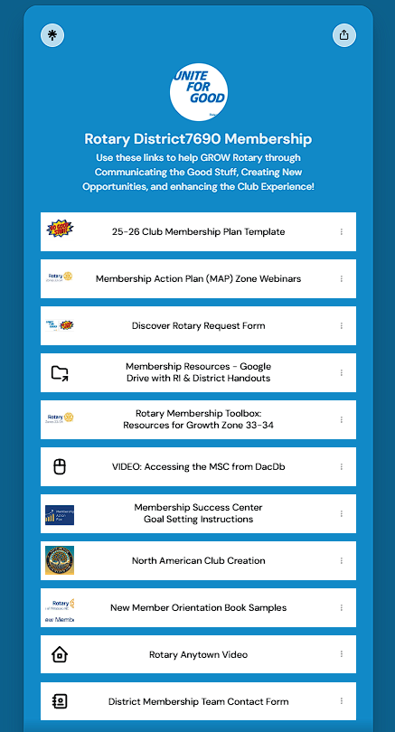



Foundation

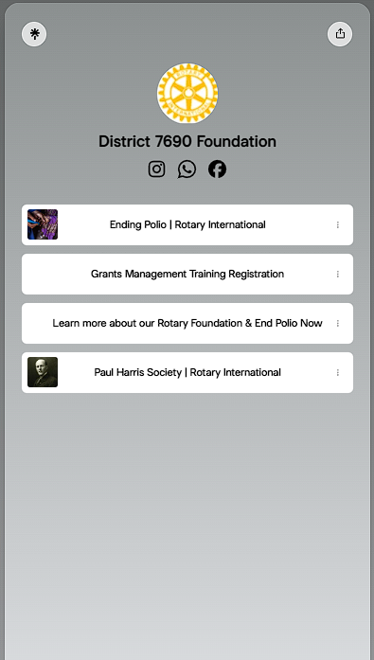



Grant Funding 2026-2027 for Qualified Clubs

Summary of Club Funding Allocations
The following table outlines the grant funding allocated to qualified clubs for the 2026-2027 period. Each club is listed alongside its respective fund allocation and share for the 2023-2024 cycle. All amounts are presented in US dollars.
Club Name | 2023-2024 Allocation | 2026-2027  Share
Alamance (Burlington), NC | $7,770.00 | $1,554.00
Asheboro, NC | $10,370.08 | $2,074.02
Burlington, NC | $3,570.00 | $714.00
Carthage, NC | $2,970.00 | $594.00
Clemmons, NC | $13,883.00 | $2,776.60
Crescent (Greensboro), NC | $14,699.00 | $2,939.80
Downtown Greensboro, NC | $18,248.00 | $3,649.60
East Greensboro, NC | $1,400.00 | $400.00
E-Club of Global Trekkers D7690, NC | $4,906.36 | $981.27
Furnitureland, NC | $12,690.00 | $2,538.00
Gate City (Greensboro), NC | $8,370.00 | $1,674.00
Graham, NC | $10,020.00 | $2,004.00
Greensboro, NC | $19,810.00 | $3,962.00
Greensboro Airport, NC | $9,200.00 | $1,840.00
Guilford (Greensboro), NC | $7,520.00 | $1,504.00
High Point, NC | $38,913.00 | $7,782.60
Jamestown, NC | $2,800.00 | $560.00
Jonesboro (Sanford), NC | $6,178.00 | $1,235.60
Kernersville, NC | $21,400.00 | $4,280.00
King, NC | $6,145.00 | $1,229.00
Lexington, NC | $3,760.00 | $752.00
Liberty, NC | $3,150.00 | $630.00
Midstate Asheboro, NC | $18,535.82 | $3,707.16
Mocksville, NC | $3,995.00 | $799.00
Mount Airy, NC | $13,029.26 | $2,605.85
Pinehurst, NC | $1,850.00 | $400.00
Pittsboro, NC | $13,493.00 | $2,698.60
Randolph (Asheboro), NC | $11,552.34 | $2,310.47
Reidsville, NC | $3,800.00 | $760.00
Reynolda (Winston-Salem), NC | $10,217.10 | $2,043.42
Sandhills (Southern Pines), The, NC | $3,177.50 | $635.50
Sanford, NC | $8,875.00 | $1,775.00
Siler City, NC | $2,807.83 | $561.57
Southern Guilford, NC | $10,790.00 | $2,158.00
Southern Pines, NC | $14,317.03 | $2,863.41
Stoneville, NC | $15.00 | $400.00
Stratford (Winston-Salem), NC | $5,120.00 | $1,024.00
Summit (Greensboro), NC | $40,460.18 | $8,092.04
Surry Sunrise, NC | $11,250.00 | $2,250.00
Thomasville, NC | $25,425.00 | $5,085.00
Troy, NC | $5,035.00 | $1,007.00
Western Forsyth, NC | $4,874.00 | $974.80
Winston-Salem, NC | $8,750.00 | $1,750.00
Yadkin County, NC | $9,752.00 | $1,950.40
Yadkin Valley (Elkin-Jonesville), NC | $3,500.00 | $700.00

Club Qualification Memorandum of Understanding
~~~~~~~~~~~~~~~~~~~~~~~~~~~~

The Rotary Foundation

- Club Qualification
- Club Officer Responsibilities
- Financial Management Plan
- Bank Account Requirements
- Report on Use of Grant Funds
- Document Retention
- Reporting Misuse of Grant Funds

Club Qualification
To participate in Rotary Foundation grants, the club must agree to implement the financial and stewardship requirements in this memorandum of understanding (MOU) provided by The Rotary Foundation (TRF) and to send at least one club member to the district’s grant management seminar each year. The district may also establish additional requirements for club qualification and/or require its clubs to be qualified in order to participate in district grants. By completing these requirements, the club becomes qualified and eligible to participate in Rotary grants.

    - Upon successful completion of the qualification requirements, the club will be qualified for one Rotary year.
    - To maintain qualified status, the club must comply with this MOU, any additional district requirements, and all applicable TRF policies.
    - The club is responsible for the use of funds for club-sponsored grants, regardless of who controls the funds.
    - Qualification may be suspended or revoked for misuse or mismanagement of grant funds involving, but not limited to: fraud; forgery; membership falsification; gross negligence; endangerment of health, welfare, or safety of beneficiaries; ineligible contributions; use of funds for personal gain; undisclosed conflicts of interest; monopolization of grant funds by individuals; report falsification; overpricing; acceptance of payments from beneficiaries; illegal activities; use of grant funds for ineligible purposes.
    - The club must cooperate with any financial, grant, or operational audits.

Club Officer Responsibilities
The club officers hold primary responsibility for club qualification and the proper implementation of TRF grants.
Club officer responsibilities include:
    - Appointing at least one club member to implement, manage, and maintain club qualification
    - Ensuring that all TRF grants adhere to stewardship measures and proper grant management practices
    - Ensuring that all individuals involved in a grant conduct their activities in a way that avoids any actual or perceived conflict of interest

Club Memorandum of Understanding (Effective: 1 July 2022)

Financial Management Plan
The club must have a written financial management plan to provide consistent administration of grant funds.

The financial management plan must include procedures to:
    - Maintain a standard set of accounts, which includes a complete record of all receipts and disbursements of grant funds
    - Disburse grant funds, as appropriate
    - Maintain segregation of duties for handling funds
    - Establish an inventory system for equipment and other assets purchased with grant funds, and maintain records for items that are purchased, produced, or distributed through grant activities
    - Ensure that all grant activities, including the conversion of funds, comply with local law

Bank Account Requirements
In order to receive grant funds, the club must have a dedicated bank account that is used solely for receiving and disbursing TRF grant funds.
    - The club bank account must:
      - Have a minimum of two Rotary member signatories from the club for disbursements
      - Be a low- or noninterest-bearing account
    - Any interest earned must be documented and used for eligible, approved grant activities, or returned to TRF.
    - A separate account should be opened for each club-sponsored grant, and the name of the account should clearly identify its use for grant funds.
    - Grant funds may not be deposited in investment accounts including, but not limited to, mutual funds, certificates of deposit, bonds, and stocks.
    - Bank statements must be available to support receipt and use of TRF grant funds.
    - The club must maintain a written plan for transferring custody of the bank accounts in the event of a change in signatories.

Report on Use of Grant Funds
The club must adhere to all TRF reporting requirements. Grant reporting is a key aspect of grant management and stewardship, as it informs TRF of the grant’s progress and how funds are spent.

Document Retention
The club must establish and maintain appropriate recordkeeping systems to preserve important documents related to qualification and TRF grants. Retaining these documents supports transparency in grant management and assists in the preparation for audits or financial assessments.

    - Documents that must be maintained include, but are not limited to:
      - Bank information, including copies of past statements
      - Club qualification documents including a copy of the signed club MOU
      - Documented plans and procedures, including:
        - Financial management plan
        - Procedure for storing documents and archives
        - Succession plan for bank account signatories and retention of information and documentation
      - Information related to grants, including receipts and invoices for all purchases
    - Club records must be accessible and available to Rotary members in the club and at the request of the district
    - Documents must be maintained for a minimum of five years, or longer if required by local law

Reporting Misuse of Grant Funds
The club must report any potential and real misuse or mismanagement of grant funds to the district. This reporting fosters an environment in the club that does not tolerate the misuse of grant funds.

Authorization and Agreement
This memorandum of understanding is an agreement between the club and the district and acknowledges that the club will undertake measures to ensure the proper implementation of grant activities and proper management of TRF grant funds. By authorizing this document, the club agrees to comply with all of the conditions and requirements of the MOU.
On behalf of the Rotary/Rotaract Club of ______________________________, the undersigned agree to comply with all of the conditions and requirements of the MOU for Rotary year 2026-2027 and will notify Rotary International District 7690 of any changes or revisions to club policies and
procedures related to these requirements.

Club President |  |  | Club President-elect
Term | 2026-2027 |  | Term | 2027-2028
Print Name |  |  | Print Name
Signature |  |  | Signature
Date |  |  | Date

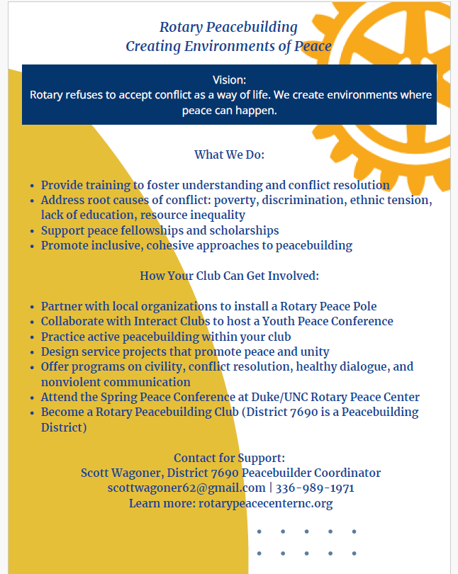

Public Image


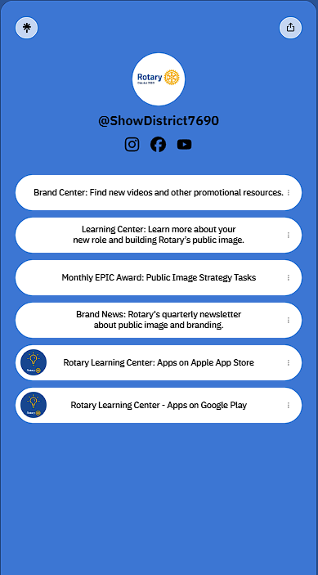

District Action

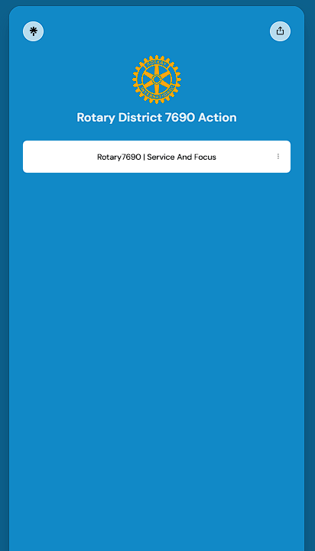



Youth

Youth Goals – Linktree and QR Code Here

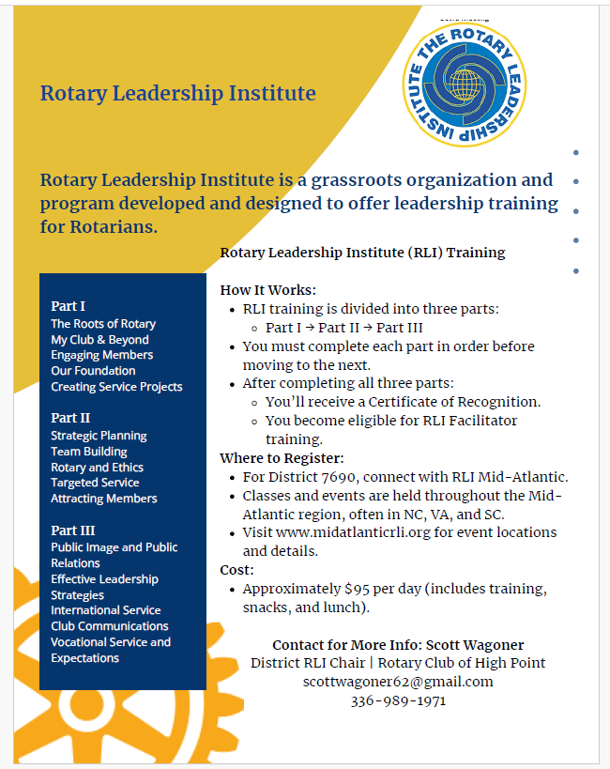

CART

CART flier here

Family of Rotary Events 2026-2027

Family of Rotary Goals – List of Events

District 7690 Crisis Management Guidelines
Rotary is a 116-year-old organization with a strong, trusted brand. It is important we continue to protect our brand by minimizing risk. In the event of a crisis, we need to be able to respond effectively, keep involved parties and Rotary International informed, and use the media, if engaged, as a liaison to disseminate key messages. The organizations response to a crisis often has more impact on reputation than the event the precipitated the situation. I suggest copying these guidelines to your mobile phone.
Should you experience a crisis during your year as Club President, take the following actions in the order listed. This list will help you handle the situation in an organized way that will mitigate risk to Rotary’s reputation and brand:
1. Give priority attention to the care of the injured. Not all crisis situations will have injured. 2. Secure needed assistance – doctor, ambulance, fire, law enforcement.
3. Ensure the safety of persons and property.
4. Contact the Crisis Manager, Steven Taylor: 919-270-7257. In the event you are unable to reach the Crisis Manager and it is urgent that you speak with a District representative, Public Image Chair Kathy Torrey will be a backup contact and may be reached at 910-603-0743. Add these numbers to your contact list in your cell phone for future reference. The Crisis Manager will contact the District Governor, Van Lankford: 336-407- 1579.
5. Gather the facts before you speak with the Crisis Manager and Youth Protection Officer if youth are involved. Your fact-based detailed report should include who, when, where, what happened, the current state of the crisis, and is media involved. Ensure the Crisis Manager is fully briefed before referring the media to her. 6. The official statement you should make to the public/media:
“At this time, we are in the process of gathering the facts related to this matter and I am not in a position to answer questions. We appreciate your interest and concern, and once we complete our investigation, we will provide an appropriate statement.”
(Example: “Our designated spokesperson with respect to this matter will be _____,
who may be reached at ____.”)
7. Keep the following in mind:
a. Do not bury your head in the sand. Pretending the problem will not exist will not make it go away. Be prepare to react quickly.
b. Do not panic. Stay calm and clearly define what has occurred. Avoid blame games or debates. Spend your initial time focused on establishing the nature and extent of the crisis, who it will affect, and what you need to do to manage the situation.
c. Get your facts straight. It is important to be able to demonstrate command of the situation and not be confused, unclear or unaware of the facts.
d. In conjunction with the District help to manage the communication. There should be only one spokesperson with respect to any statements made about the crisis. If you are selected to be the point of contact, be prepared to communicate clearly, honestly, and as often as needed. Without clear communication, people will fill the void with rumors and speculation.
e. Be honest in everything you say and do.
f. Do not play favorites with media or others. At the appropriate time, communications should be made clearly and concisely to all stakeholders.

District 7690 Crisis Management Guidelines
8. When the crisis manager receives your call, she will work with you to determine the severity of the crisis, contact Rotary International 847-424-5394 and add District Rotarians to the crisis team, as needed. A designated spokesperson will be named to handle future inquiries from Rotary International, the public, or media. At the conclusion of the crisis, a written report will be completed and approved by the District Governor for the District’s records. Any recommended changes to the Crisis Management Plan will be reviewed for implementation.
9. Helpful references to use in a crisis:
a. District 7690 Insurance Representative
Mark Brandon
336-407-0643
markbrandon@wnireland.com
b. Active U.S. Rotary clubs and districts and Rotaract clubs are provided with general liability ("GL") insurance through the U.S. Rotary Club and District Liability Insurance Program ("Program"). https://my.rotary.org/en/us-rotary-club-and-district-liability-insurance-program
To report an incident or claim, please email claims@rotary.org.
To obtain a certificate of insurance, insurance policies and summaries, loss prevention strategies, and more, please visit the insurance broker’s website, Gallagher Insurance Website. Gallagher Insurance Website can be accessed with a username and password that have been emailed to your club and district officers through annual insurance
e-mailings or you can contact Rotary International Risk Management.
If you have questions regarding coverage, please contact insurance broker, Gallagher:
Email: rotary@ajg.com
Phone: 833-376-8279
Website: https://rotary.ajg.com
c. Rotary International Code of Policies can be located at: https://my.rotary.org/en/document/622
d. District 7690 Youth Protection Policy
District 7690 Youth Protection Policy
e. Rotary International Youth Protection Guide
RI Publication 775en-(816)

U.S. Rotary Club and District Liability Insurance Program

Active U.S. Rotary clubs and districts and Rotaract clubs are provided with general liability (“;GL”) and
directors &amp; officers/employment practices liability (D&O/EPL”;) insurance through the U.S. Rotary Club
and District Liability Insurance Program (“Program”). The Program is financed by insurance assessments
collected from U.S. Rotarians on the July Club Invoice.

To report an incident or claim, please email Rotary International Risk Management. To obtain a
certificate of insurance, insurance policies and summaries, loss, strategies, and more, please visit the
insurance broker’s website, Long Insurance Services, can be accessed with a username and password
that have been emailed to your club and district officers through annual insurance e-mailings or you can
contact Rotary International Risk Management.

If you have questions regarding coverage, please contact the insurance broker, Long Insurance Services.
Email: rotary@ajg.com Phone: 833-376-8279 Website: https://rotary.ajg.com.

District 7690 Insurance Representative Duane Long
Email: duanelong@long-insurance.com
Phone number: 336-992-5664.

2026-2027 District Conference Flyer

Coming Soon!

